EXPERIMENT – 3
3. Perform basic Image Handling and processing operations on the image is
to read an image in python and Convert an Image to show outline using
Canny function.
Aim
To read an image using Python and OpenCV and detect the outline/edges of the image using
the Canny edge detection function.
Procedure
1. Import the OpenCV library.
2. Read the input image using cv2.imread().
3. Convert the image to grayscale using cv2.cvtColor().
4. Apply the Canny edge detection function using cv2.Canny().
5. Display the original image and the detected outline.
6. Wait for a key press and close the image windows.
Program
import cv2
image = cv2.imread("image.jpg")
if image is None:
print("Image not found!")
else:
gray = cv2.cvtColor(image, cv2.COLOR_BGR2GRAY)
edges = cv2.Canny(gray, 100, 200)
cv2.imshow("Original Image", image)
cv2.imshow("Canny Edge Image", edges)
cv2.waitKey(0)
cv2.destroyAllWindows()
Sample Input
image.jpg

Sample Output
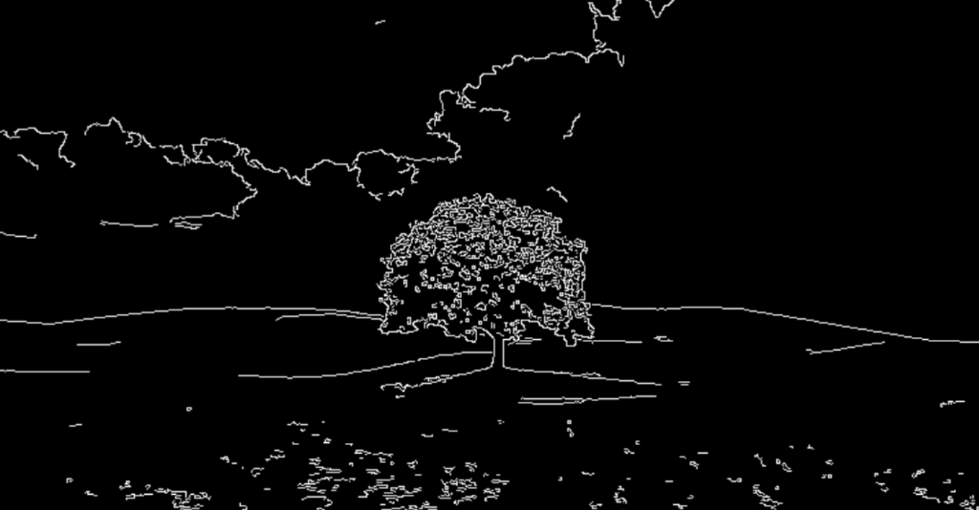
Result
Thus, the image was successfully read and its outline was detected using the Canny edge
detection function in Python and OpenCV

